MANAGEMENT INFORMATION SYSTEM

LAB EXPERIMENTS

PAGADALA ASHOK(192110152)

3) Make an Online Airline Reservation System. The activities of the Online Airline  Reservation system are listed below user, admin, LOGIN, MANANGE CLASSES,  MANANGE WAITING LIST, MANAGE HOLDS, MANAGE DEADLINES,  LOGOUT, using this has a step-by-step process draw a CLASS diagram.

**Aim:**

To develop a **UML Class Diagram** for an **Online Airline Reservation System**, which models the interactions between users, admins, and various reservation management functionalities.

**Procedure:**

1. **Identify Key Classes:**
   * **User**: Represents passengers booking flights.
   * **Admin**: Manages the system.
   * **Flight**: Contains details about flights.
   * **Reservation**: Manages bookings.
   * **WaitingList**: Handles passengers on standby.
   * **Hold**: Manages temporary reservations.
   * **Deadline**: Sets time limits for reservations.
2. **Define Attributes and Methods:**
   * **User**: userID, name, email, login(), logout(), makeReservation()
   * **Admin**: adminID, manageClasses(), manageWaitingList(), manageHolds(), manageDeadlines()
   * **Flight**: flightID, origin, destination, departureTime, availability
   * **Reservation**: reservationID, userID, flightID, status, confirmBooking(), cancelBooking()
   * **WaitingList**: addToWaitingList(), removeFromWaitingList()
   * **Hold**: placeHold(), releaseHold()
   * **Deadline**: setDeadline(), checkDeadline()
3. **Establish Relationships:**
   * A **User** can make multiple **Reservations**.
   * A **Reservation** is linked to a **Flight**.
   * The **Admin** manages **Classes**, **Waiting List**, **Holds**, and **Deadlines**.

**Output:**

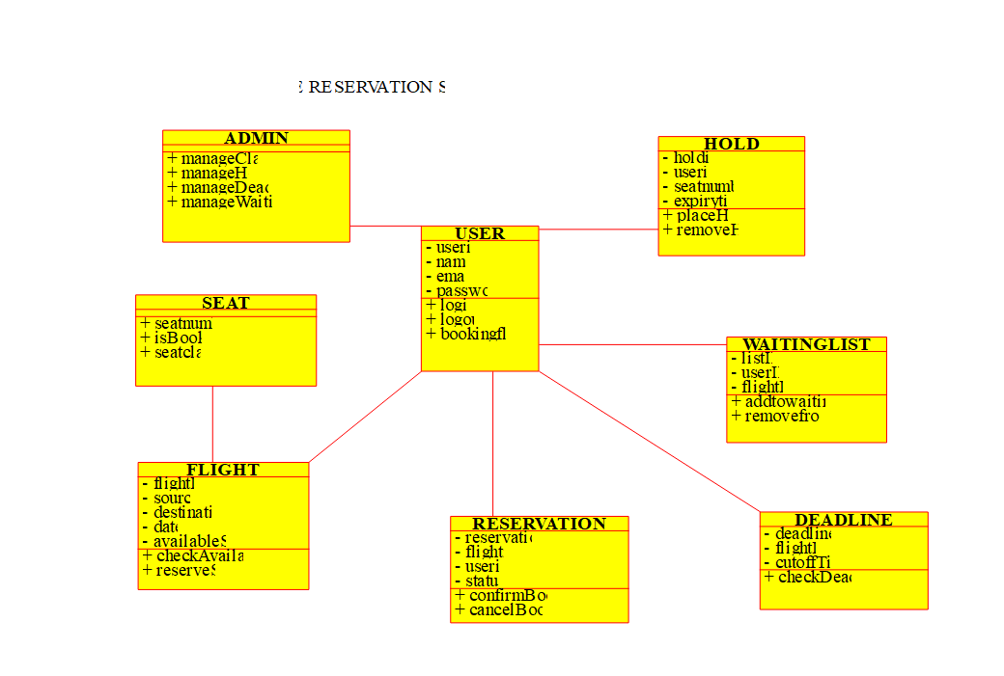

**Class diagram**

**Result:**

A **UML Class Diagram** will be created based on the above design.